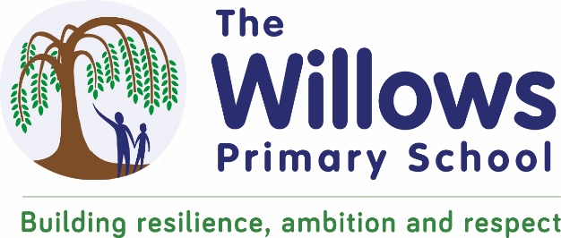

Physical Education - Long Term Plan.

 |  | AUTUMN 1 | AUTUMN 2 | SPRING 1 | SPRING 2 | SUMMER 1 | SUMMER 2
Nursery |  | Birth to 3: Walking, running, jumping in different way | 3 and 4 year olds: Kicking, throwing, catching balls | 3 and 4 year olds: Skipping, hopping and standing on one leg. Participating in group activities which they make up themselves, or in teams | 3 and 4 year olds: Develop movement, balancing & ball skills. Use large muscle movements | 3 and 4 year olds: Able to use and remember sequences And patterns of movements which are related to music and rhythm | 3 and 4 year olds: Continue to develop their movement & balancing, skills. Go up steps and stairs, or climb up apparatus, using alternate feet
Reception |  | Gymnastics | Dance | Body Management | Cooperate & Solve Problems | Manipulation & Co-ordination | Speed Agility Travel
Year 1 | Class Teacher | Gymnastics 1 | Dance 1 | Gymnastics 2 | Dance 2 | Gym 3 | Dance 3
 | Sports Point Coach | Send & return | Attack, defend, shoot | Run, jump, throw | Hit, catch & run | Send & return | Run, jump & throw
Year 2 | Class Teacher | Gymnastics 1 | Dance 1 | Gymnastics 2 | Dance 2 | Gym 3 | Dance 3
 | Sports Point | Send & return | Attack, defend, shoot | Run, jump, throw | Hit, catch & run | Run, jump & throw | Hit, catch & run
Year 3 | Class Teacher | Gymnastics 1 | Dance 1 | Gymnastics 2 | Dance 2 | Gymnastics 3 | Dance 3
 | Sports Point | Hockey | Handball | Basketball | Tag rugby | Swimming | Swimming
Year 4 | Class Teacher | Gymnastics 1 | Dance 1 | Gymnastics 2 | Dance 2 | Gymnastics 3 | Dance 3
 | Sports Point | Swimming | Swimming | Swimming | Swimming | Cricket | Athletics
Year 5 | Class Teacher | Gymnastics 1 | Dance 1 | Gymnastics 2 | Dance 2 | Gymnastics 3 | Dance 3
 | Sports Point | Hockey | Football | Basketball | Tag rugby | Cricket | Athletics
Year 6 | Class Teacher | Gymnastics 1 | Dance 1 | Gymnastics 2 | Dance 2 | Gymnastics 3 | Dance 3
 | Sports Point | Hockey | Basket ball | Football | Tag rugby | Cricket | Athletics

